What was it like to be a Roman soldier?
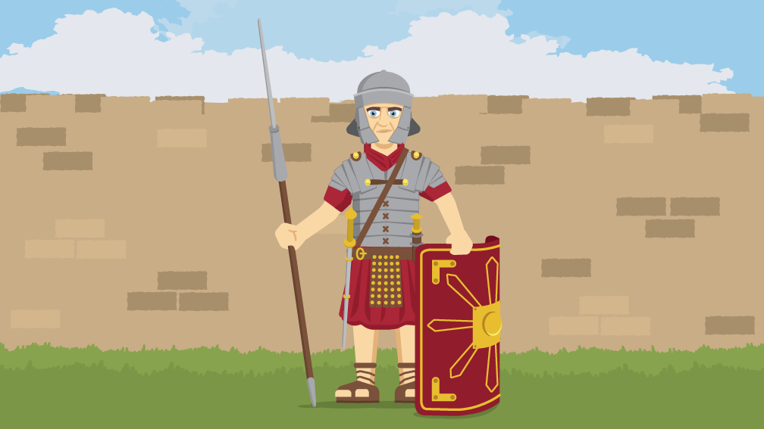
Our new topic this term is about the Romans and Hadrian’s Wall.

Have a look at this website and the clip it contains…
https://www.bbc.co.uk/bitesize/topics/zwmpfg8/articles/zqbnfg8

Make a poster about Roman soldiers.

What equipment did the soldiers have?
What made the Roman army so successful?
What was everyday life like for the soldiers?
Why did the Romans invade Britain?

