Make your own Earth
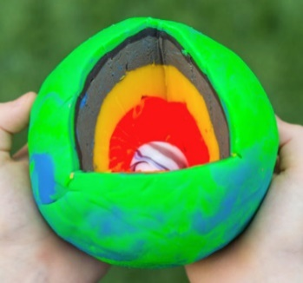
As we are learning about Dynamic Earth you may want to create your own planet to investigate the different layers.
Be Creative – if you don’t have all of the resources, see if you can find something else to use instead!
It does not have to be perfect or made to scale, but it may help you understand the composition of the earth.

The Picture shows all the layers
Inner core – marble
Outer core – orange playdough
Lower Mantle – yellow playdough
Upper Mantle – grey playdough
Crust – green / blue playdough

YouTube Video about the Layers of the Earth
https://www.bing.com/videos/search?q=utbe+earths+layers+y3&&view=detail&mid=60228D6F2F79B26B2CDD60228D6F2F79B26B2CDD&&FORM=VDRVRV

If you don’t have any modelling materials at home, you could try to make your own playdough.
Play Dough Recipe
https://www.bbcgoodfood.com/howto/guide/playdough-recipe

