The development of children’s spoken language underpins all seven areas of learning and development. Children’s back-and-forth interactions from an early age form the foundations for language and cognitive development. The number and quality of the conversations they have with adults and peers throughout the day in a language-rich environment is crucial. By commenting on what children are interested in or doing, and echoing back what they say with new vocabulary added, practitioners will build children's language effectively. Reading frequently to children, and engaging them actively in stories, non-fiction, rhymes and poems, and then providing them with extensive opportunities to use and embed new words in a range of contexts, will give children the opportunity to thrive. Through conversation, story-telling and role play, where children share their ideas with support and modelling from their teacher, and sensitive questioning that invites them to elaborate, children become comfortable using a rich range of vocabulary and language structures.

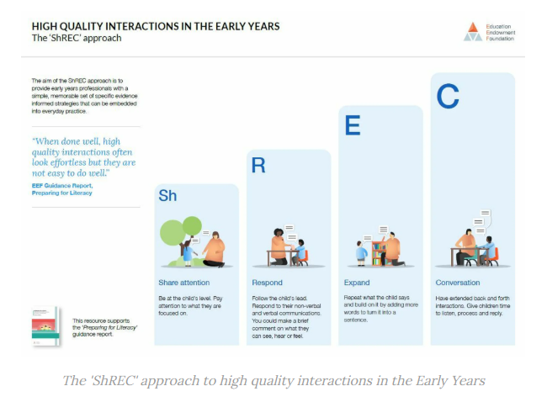

|  |  |  |
| --- | --- | --- |
| Communication and Language – Listening and Attention | | |
| **Three- Four Years**  . Enjoy listening to longer stories and can remember much of what happens. C&L.3-4(a)  • Can find it difficult to pay attention to more than one thing at a time. C&L.3-4(b)  . Use a wider range of vocabulary. C&L.3-4(c)  . Understand a question or instruction that has two parts, such as “Get your coat and wait at the door.” C&L.3-4(d)  . Understand ‘why’ questions, like “ Why do you think the caterpillar got so fat?” C&L.3-4(e) | **Reception**  . Understand how to listen carefully and why listening is important. C&L.REC(a)  . Learn new vocabulary. C&L.REC(b)  . Use new vocabulary through the day. C&L.REC(c)  . Listen to and talk about stories to build familiarity and understanding. C&L.REC(k)  . Listen carefully to rhymes and songs, paying attention to how they sound. C&L.REC(n)  . Learn rhymes, poems and songs. C&L.REC(o)  . Engage in non-fiction books. C&L.REC(p)  . Listen to and talk about selected non-fiction to develop a deep familiarity with new knowledge and vocabulary. C&L.REC(q) | ELG  .Listen attentively and respond to what they hear with relevant questions, comments and actions when being read to and during whole class discussions and small group interactions. C&L.LAU.ELG  • Make comments about what they have heard and ask questions to clarify their understanding. C&L.LAU.ELG  • Hold conversation when engaged in back-and-forth exchanges with their teacher and peers. C&L.LAU.ELG |
| Reception Autumn Term | Reception Spring | Reception Summer Term |
| Understand how to listen carefully and why listening is important. Learn new vocabulary. Engage in story times. Listen carefully to rhymes and songs, paying attention to how they sound. Engage in non-fiction books. | Ask questions to find out more and to check they understand what has been said to them. Listen to and talk about stories to build familiarity and understanding. Retell the story, once they have developed a deep familiarity with the text; some as exact repetition and some in their own words. Learn rhymes, poems and songs. Listen to and talk about selected nonfiction to develop deep familiarity with new knowledge and vocabulary. | Listen attentively and respond to what they hear with relevant questions, comments and actions when being read to and during whole class discussions and small group interactions. Make comments about what they have heard and ask questions to clarify their understanding. Hold conversation when engaged in back-and-forth exchanges with their teacher and peers. |
| How is this reflected in provision and support? | | |
| Storytimes embedded throught daily practise, singing and rhymes, circle times, assemblies, group times, music sessions, special visitors, topci time to learn new voacbulary and ask questions, continuous provsion time engaged with peers, working with adults across the setting, listening stations, reading areas with varieties of books and topics, open-ended play resources to promote questions. | | |

|  |  |  |  |
| --- | --- | --- | --- |
| Communication and Language – Speaking | | | |
| Three- Four Years  Sing a large repertoire of songs. C&L.3-4(f)  • Know many rhymes, be able to talk about familiar books, and be able to tell a long story. C&L.3-4(g)  . Develop their communication but may continue to have problems with irregular tenses and plurals, such as ‘runned’ for ‘ran’ ‘swimmed’ for ‘swam’. C&L.3-4(h)  . May have problems saying”- Some sounds: r, j, th, ch, and sh – multi-syllabic words such as ‘pterodactyl’, ‘planetarium’, or ‘hippopotamus’. C&L.3-4(i)  . Use longer sentences of four to six words. C&L.3-4(j)  . Be able to express a point of view and to debate when they disagree with an adult or a friend, using words as well as actions. C&L.3-4(k)  . Can start a conversation with an adult or a friend and continue it for many turns. C&L.3-4(l)  . Use talk to organise themselves and their play: “Let’s go on a bus… you sit there… I’ll be the bus driver.” C&L.3-4(m) | | Reception.  Learn new vocabulary. C&L.REC(b)  . Use new vocabulary through the day. C&L.REC(c)  . Ask questions to find out more and to check they understand what has been said to them. C&L.REC(d)  . Articulate their ideas and thoughts in well-formed sentences. C&L.REC(e)  . Connect one idea or action to another using a range of connectives. C&L.REC(f)  . Describe events in some detail. C&L.REC(g)  .Use talk to help work out problems and organise thinking and activities explain how things work and why they might happen. C&L.REC(h)  . Develop social phrases. . C&L.REC(i)  . Engage in story times. . C&L.REC(j) | ELG .  . Participate in small group, class and one-to-one discussions, offering their own ideas, using recently introduced vocabulary. C&L.SP.ELG  • Offer explanations for why things might happen, making use of recently introduced vocabulary from stories, non-fiction, rhymes and poems when appropriate. C&L.SP.ELG  • Express their ideas and feelings about their experiences using full sentences, including use of past, present and future tenses and making use of conjunctions, with modelling and support from their teacher. C&L.SP.ELG |
| Reception Autumn Term | Reception Spring | | Reception Summer Term |
| Use new vocabulary through the day. Articulate their ideas and thoughts in well-formed sentences. Connect one idea or action to another using a range of connectives.  I am using longer sentences of 4 – 6 words. | Describe events in some detail. Use talk to help work out problems and organise thinking and activities, and to explain how things work and why them might happen. Develop social phrases. Use new vocabulary in different contexts  Articulate my ideas and thoughts through well-articulated sentences.  Be able to talk with peers in play to organise games and role play. | | Participate in small group, class and one-to-one discussions, offering their own ideas, using recently introduced vocabulary. Offer explanations for why things might happen, making use of recently introduced vocabulary from stories, non-fiction, rhymes and poems when appropriate. Express their ideas and feelings about their experiences using full sentences, including use of past, present and future tenses and making use of conjunctions, with modelling and support from their teacher |
| How is this reflected in provision and support? | | | |
| Continuous provision set up to provoke conversation, Talk for Writing to rehearse and practise key stories, story times throughout the day, shared discussions to collect vocabulary and ideas, free flow snack table to promote conversations with peers, assemblies, singing practise, shared games and play opportunities, buddy systems, home learning, Talk Boost, mixed groupings to provide strong language groupings, differentiated questioning, parental engagement, vocabulary packs, planned vocabulary, look for understanding through play, SHreck model, high quality staff interactions, planned oracy times, planned scaffolding to extend and model time, adults timetables to engage in play, parental workshops  IMG_1666 | | | |