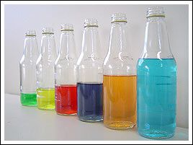
Glass Bottle Orchestra experiment

- Why do you think the bottles are lined up like this?
- What do you think will happen to each bottle when they're tapped?
- Why do you think there are different levels of liquid in each bottle?
- How do you think the sound is made?
Make your own version of the glass bottle orchestra.
How does the amount of water in each bottle affect the sound you get when you tap it?

