Literacy - Writing
Three- Four Years  . Use some of their print and letter knowledge in their early writing. For example: writing a pretend shopping list that starts at the top of the page; write ‘m’ for mummy. Writing.3-4  • Write some or all of their name. Writing.3-4  . Write some letters accurately. Writing.3-4  Handwriting  .Use a comfortable grip with good control when holding pens and pencils. PD FMS.3-4  .Show a preference for a dominant hand. PD FMS.3-4 | Reception  . Form lower-case and capital letters correctly. Writing-Reception  . Spell words by identifying the sounds and then writing the sound with letter/s. Writing-Reception  . Re-read what they have written to check that it makes sense. Writing-Reception  . Write short sentences with words with known letter-sound correspondences using a capital letter and full stop. Writing-Reception  Handwriting  Develop their small motor skills so that they can use a range of tools competently, safely and confidently. Suggested tools: pencils for drawing and writing. PD.FMS - Reception  Develop the foundations of a handwriting style which is fast, accurate and efficient. PD.FMS - Reception. |  |  | Writing- ELG .  . Write recognisable letters, most of which are correctly formed. Writing-ELG  • Spell words by identifying sounds in them and representing the sounds with a letter or letters. Writing-ELG  • Write simple phrases and sentences that can be read by others. Writing-ELG  Handwriting  . Hold a pencil effectively in preparation for fluent writing- using the tripod grip in almost all cases. FMS-ELG
Reception Autumn Term |  | Reception Spring | Reception Summer Term
Form lowercase letters and capital letters correctly Spell words by identifying the sounds and then writing the sound with letter/s. Copy full name from a name label.  Physical Development Use a range of small tools competently and confidently. |  | Write short sentences with words with known sound- letter correspondences, using a capital letter and a full stop. Begin to use capital letters, finger spaces and full stops in independent writing.  Physical Development Develop the foundations of a handwriting style which is fast, accurate and efficient. Begin to use tripod grip. | Use a capital letter at the beginning of a sentence and a full stop at the end. Use finger spaces most of the time. Is able to write their first name and starting to write their surname independently. Write recognisable letters, most of which are correctly formed. Spell words by identifying sounds in them and representing the sounds with a letter or letters. Write simple phrases and sentences that can be read by others.  Physical Development Hold a pencil effectively in preparation for fluent writing. Using the tripod grip in almost all cases
How is this reflected in provision and support?
Pencil grips Letter formation cards/name cards. Scaffolds/Differentiation to support developmental writing. Physical resources to support with showing understanding of blending/CVC words Physical Development plan to support development of fine motor skills. Squiggle While you Wiggle sessions to build gross motor. Writing opportunities in provision – clip boards, whiteboards, paint brushes, chalk, markers to make large movements, shopping lists, diaries, message book, recipe cards, letters to post. Mark-meaning given purpose and status within provision - posters for toys, labels for the snack table. Daily practise of names, writing words and then sentences. Modelling by adults in the setting. Writing and mark-making at different levels and on different surfaces to support/engage/scaffold.
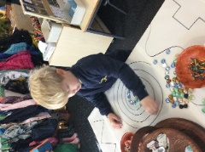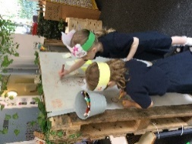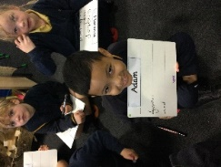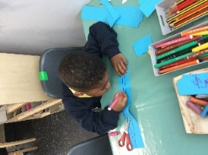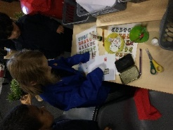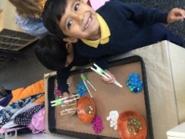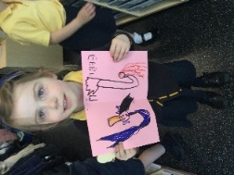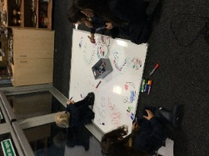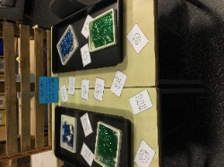

Literacy – word reading
Three to Four Years  Develop their phonological awareness, so that they can:  - spot and suggest rhymes  - count or clap syllables in a word  Recognise words with the same initial sound, such as money and mother | Reception  Read individual letters by saying the sounds for them.  • Blend sounds into words, so that they can read short words made up of known letter-sound correspondences.  • Read some letter groups that each represent one sound and say sounds for them.  • Read a few common exception words matched to the school’s phonic programme.  • Read simple phrases and sentences made up of words with known letter–sound correspondences and, where necessary, a few exception words.  • Re-read these books to build up their confidence in word reading, their fluency and their understanding and enjoyment.  • Re-read what they have written to check that it makes sense. |  |  | Word Reading- ELG .  Say a sound for each letter in the alphabet and at least 10 digraphs. WR-ELG  • Read words consistent with their phonic knowledge by sound-blending. WR-ELG  • Read aloud simple sentences and books that are consistent with their phonic knowledge, including some common exception words. WR-ELG
Reception Autumn Term |  | Reception Spring | Reception Summer Term
Develop their phonological awareness to:  Spot rhymes in familiar stories and poems.  Count or clap syllables in a word. Recognise words with the same initial sound. Begin to read individual letters by saying the sounds for them. Begin to blend sounds into words, so that they can read short words made up of known letter– sound correspondences. Begin to read CVC words containing known letter-sound correspondences. In conversations, demonstrate an understanding that print has meaning and can have different purposes. Understand text is read left to right and top to bottom with some ability to follow a text with fingers. Understand some words cannot be sounded out. Read a few common exception words. |  | Develop their phonological awareness to;  Be able to complete a rhyming string. Begin to use sound buttons to identify how many sounds are in a word. Can supply words with the same initial sound. Recognise all taught Set 1 & 2 sounds, including some digraphs. Re-read phonetically decodable books to build up their confidence in word reading, their fluency and their understanding and enjoyment. Blend sounds into words, so that they can read short words made up of known letter– sound correspondences. Read simple sentences containing known letter sound correspondences containing 1 or 2 common exception words. Read common exception words when they are included in simple phrases or sentences. Read simple phrases and sentences with some fluency. | Develop their phonological awareness to:  Recognise and use rhyme in daily conversation. Use sound buttons to segment and read words. Identify words containing the same digraph or trigraph e.g. ay- may, day, play. Say a sound for each letter in the alphabet and at least 10 diagraphs Read words consistent with their phonic knowledge by sound-blending. Read aloud simple sentences and books that are consistent with their phonic knowledge, including some common exception words.
How is this reflected in provision and support?
Songs/rhymes and stories embedded in timetables to support phonological awareness. Ensure pupils have access to interventions to support with developing phonetical understanding. Exposure to appropriate books/stories to support development. Picture prompts to support with letter recognition. Flash cards to develop understanding. Children given phonetically plausible books in their reading areas. Hands on and practical sessions based on children’s visual memory and discrimination – shadow games, silhouette matching, jigsaws and puzzles, sorting activities.
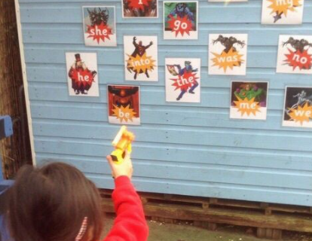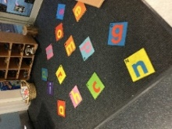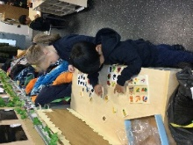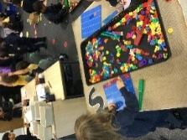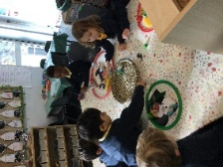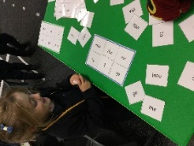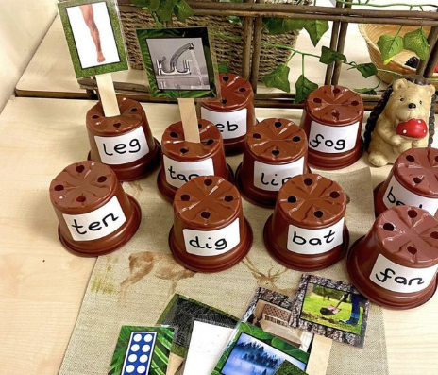

Literacy – Comprehension
Three to Four  Understand the five key concepts about print:  - print has meaning - the names of the different parts of a book  - print can have different purposes - page sequencing  we read English text from left to right and from top to bottom  Engage in extended conversations about stories, learning new vocabulary. |  | Reception  Read individual letters by saying the sounds for them.  • Blend sounds into words, so that they can read short words made up of known letter-sound correspondences.  • Read some letter groups that each represent one sound and say sounds for them.  • Read a few common exception words matched to the school’s phonic programme.  • Read simple phrases and sentences made up of words with known letter–sound correspondences and, where necessary, a few exception words.  • Re-read these books to build up their confidence in word reading, their fluency and their understanding and enjoyment.  • Re-read what they have written to check that it makes sense. |  | Comprehension- ELG .  Demonstrate understanding of what has been read to them by retelling stories and narratives using their own words and recently introduced vocabulary. COMP-ELG  • Anticipate (where appropriate) key events in stories. COMP-ELG  • Use and understand recently introduced vocabulary during discussions about stories, non-fiction, rhymes and poems and during role play COMP-ELG
Reception Autumn Term | Reception Spring |  | Reception Summer Term
Asks questions about stories. Repeat words and phrases from familiar stories. Repeat new vocabulary in a context of a story. Has favourite books and seeks them out, to share with an adult, with another child, or to look at alone. Engages in conversations about stories while answering questions. Notices words they do not know the meaning of. Engages in discussions about words they do not know the meaning of. Begins to look more in detail at the pictures and talk about what is happening. Makes basic inferences on characters feelings. Share opinions of stories – likes and dislikes. Can re-tell a story through images. | Answer questions about a text that has been read to them showing some confidence and logic. Begin to predict what might happen next in a story. Begin to use modelled vocabulary during role play for example in the Small World. Seeks familiar texts or stories to re-read in the book area. Requests favourite stories and poems. Asks more in-depth questions about a text showing a good understanding of the text. Makes rational anticipations of key events in a story through inferences. Make links between what has been read to them and their own life experiences. Explain what has been read to them in their own words. Recognise the difference between non-fiction and fiction texts. Recognises characters, events, titles, images and key information in a text. Can orally re-tell a story in their own words. |  | Can share a favourite book with a peer, retelling the story in their own way repeating known phrases from the text. Demonstrate understanding of what has been read to them by retelling stories and narratives using their own words and recently introduced vocabulary. Anticipate – where appropriate – key events in stories. Use and understand recently introduced vocabulary during discussions about stories, non-fiction, rhymes and poems and during role-play.  Express their ideas and views about the characters and events in the story. Retrieves information by finding key words in a text. Can sequence a class story remembering some details and key events including story specific vocabulary too.
How is this reflected in provision and support?
Use of Makaton/picture prompts/communication boards to support communication about stories read and to support with answering questions Picture prompts to support with discussion around stories Use of story sacks/ role play to support with understanding of stories Exposure to familiar books regularly. Re-read books with similar structure to develop understanding. Song time. Story-times to Learn new vocabulary, engage in and talk about rhyme, anticipate repetitive language, learn rhymes, poems and songs. Selection of treasured and thoughtfully-chosen core books which children revisit again and again. Opportunities to act out stories in small worlds and role play. Selection of different texts exposed to the children and available throughout provision. Trips to libraries and local author visits to engage enthusiasm. Children given access to weekly library book to take home. 1:1 reading each week with guided reading introduced at a later stage. Hooks for topics linked to texts. Labels and posters available in areas to engage children with linking meanings to marks. Talk for Writing throughout the year with carefully chosen texts to support vocabulary development and to extend children’s story-telling language. Listening corners with stories to listen to.
