Physical Devlopment and activity is vital in children’s all-round development, enabling them to pursue happy, healthy and activie lives. Gross and Fine Motor experiences develop incrementally throughout early childhood and by creating games and providing opportunities for play both indoors and outdoors, adults can support children to develop their core strength, stability, balance, special awreness, co-ordination and agility. Gross motors kills provide the foundation for developing healthy bodies and social and emaotional well-being. Fine motor control and precision helps with hand-eye co-ordination. Fine motor control and precision helps with hand-eye co-ordination which is later linked to early literacy
Gross Motor Control
Three- Four Years  . Continue to develop their movement, balancing, riding (scooters, trikes and bikes) and ball skills.  • Go up steps and stairs, or climb up apparatus, using alternate feet.  • Skip, hop, stand on one leg and hold a pose for a game like musical statues  • Use large-muscle movements to wave flags and streamers, paint and make marks.  . Start taking part in some group activities which they make up for themselves, or in teams.  Are increasingly able to use and remember sequences and patterns of movements which are related to music and rhythm.  . Match their developing physical skills to tasks and activities in the setting. For example, they decide whether to crawl, walk or run across a plank, depending on its length and width  . Choose the right resources to carry out their own plan. For example, choosing a spade to enlarge a small hole they dug with a trowel.  • Collaborate with others to manage large items, such as moving a long plank safely, carrying large hollow blocks. |  | Reception  . Revise and refine the fundamental movement skills they have already acquired: - rolling- crawling - walking - jumping - running - hopping - skipping – climbing.  . Progress towards a more fluent style of moving, with developing control and grace. (balance, stillness, climb higher, fun further)  . Develop the overall body strength, co-ordination, balance and agility needed to engage successfully with future physical education sessions and other physical disciplines including dance, gymnastics, sport and swimming. (slide, bounce, rock, spin, tilt, fall, wheeled toys and bikes)  . Use their core muscle strength to achieve a good posture when sitting at a table or sitting on the floor.  . Combine different movements with ease and fluency. (obstacle courses- change speed/ direction)  . Confidently and safely use a range of large and small apparatus indoors and outside, alone and in a group.  . Develop overall body-strength, balance, co-ordination, and agility.  . Further develop and refine a range of ball skills, including throwing, catching, kicking, passing, batting, and aiming.  • Develop confidence, competence, precision and accuracy when engaging in activities that involve a ball. |  | ELG  Negotiate space and obstacles safely, with consideration for themselves and others.  • Demonstrate strength, balance and coordination when playing.  • Move energetically, such as running, jumping, dancing, hopping, skipping and climbing.
Reception Autumn Term | Reception Spring |  | Reception Summer Term
Revise and refine the fundamental movement skills they have already acquired: - Rolling - Crawling - Walking - Jumping - Running - Hopping - Skipping – Climbing Progress towards a more fluent style of moving, with developing control and grace. Confidently and safely use a range of large and small apparatus indoors and outside, alone and in a group.  Combine some movements when moving through an obstacle course.  Practsie skills of holding, rolling and throwing a ball.  Show an understanding of precise vocabulary to describe movement and directionality.  Talk about and show an understanding of some healthy routines such as getting enough sleep and exercising.  Use large construction to build. | Use their core muscle strength to achieve a good posture when sitting at a table or sitting on the floor.  Combine a variety of different movements with ease and fluency.  Further develop and refine a range of ball skills including: throwing, catching, kicking, passing, batting and aiming.  Demonstrate an ability to move with quick changes of speed and direction – for example run around in a circle, stop change direction and walk on your kneews the other way.  Model precise vocabulary to describe movement and directionality and encourage children to use it.  Develop the ability to move in ways that demand a quick change of speed and direction (eg, run around in a circle, stop, change direction and walk on your knew going the other way)  Begin to replicate dances and choreographed routines from around the world.  Be able to balance on and off equipment and jump safely onto the floor. |  | Develop the overall body strength, co-ordination, balance and agility needed to engage successfully with future physical education sessions and other physical disciplines including dance, gymnastics, sport and swimming.  Sit up tall at the table when writing with feet on the floor.  Develop confidence, precision and accuracy when engaging in activities that involve a ball. Negotiate space and obstacles safely, with consideration for themselves and others. Introduce some team games with teams, rules, targets and the need to watch and observe others.  Begin to choreograph own routines with some steps learnt by heart. Children can show some precision in their movements to start and end a sequence.  Demonstrate strength, balance and coordination when playing. Move energetically, such as running, jumping, dancing, hopping, skipping and climbing.  Know and talk about the different factors that support their overall health and wellbeing.  Travel at differing speeds on command or need.  Introduce children to ball games with teams, rules and targets.  Develop confidence, competence, precision and accuracy when engaging with activities that involve a ball.
How is this reflected in provision?
Provide regular access to appropriate outdoor space and floor space indoors for movement. Plan for different surfaces for children to move along Children are given a range of equipment to use and refine. These include wheeled toys, wheelbarrows, tumbling mats, spinning cones, tunnels, tyres, structures to jump pn and off, den-making materials, logs and planks to balance on, ladders, firemans pole. Climbing frame is part of every-day provision and the outdoor space is open throughout the day whatever the weather. Movement to develop stamina and fundamental skills is planned into the daily timetable. Regular singing of songs and games which require movement and play. Dance and different types of movement linked to music. Watching, reading about, meeting sports people. Sharing personal achievements in games and sport through online posts on Tapestry and certificates brought in from home. Using large equipment to move, pull, manipulate and balance on.
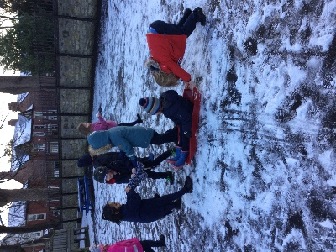
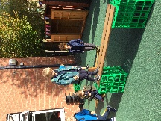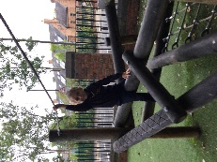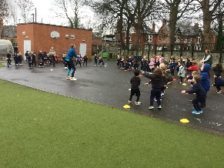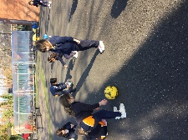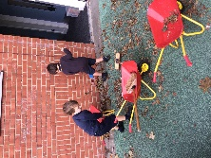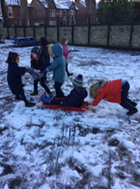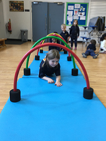

Fine Motor Control
Three- Four Years  • Use one-handed tools and equipment, for example, making snips in paper with scissors. • Use a comfortable grip with good control when holding pens and pencils. • Show a preference for a dominant hand. | Reception  • Develop their small motor skills so that they can use a range of tools competently, safely and confidently. Suggested tools: pencils for drawing and writing, paintbrushes, scissors, knives, forks and spoons.  Develop the foundations of a handwriting style which is fast, accurate and efficient. |  |  | ELG  Hold a pencil effectively in preparation for fluent writing – using the tripod grip in almost all cases.  • Use a range of small tools, including scissors, paintbrushes and cutlery.  • Begin to show accuracy and care when drawing.
Reception Autumn Term |  | Reception Spring | Reception Summer Term
Develop their small motor skills so that they can use a range of tools competently, safely and confidently; pencils for drawing and writing, paintbrushes, scissors, knives, forks, spoons.  Attempts tripod grip with some consistency.  Chooses to draw, representing recognisable objects or shapes in their work.  Can mould and shape dough with fingers and tools.  Be able to pivot wrist for smaller scale movements to grasp and grip small-scale marks with finer tools.  Form most letters in my name. |  | Develop the foundations of a hand writing style which is fast, accurate and efficient.  Holds pencil in tripod grip.  Mould clay with fingers and tools  Uses scissors to cut more complex shapes.  Be able to isolate and move different fingers (for example, show fingers for numbers, use fingers to press, pinch and hold)  Form the letters for my first name correctly.  Form most of the letters from the 26 letters in the alphabet. | Hold a pencil effectively in preparation for fluent writing – using the tripod grip in almost all cases.  Use a range of small tools, including scissors, paintbrushes and cutlery. Begin to show accuracy and care when drawing.  Record small, neat and consistently sized letters.
How is this reflected in provision?
Repeated and varied opportunities to explore and play with small world activities and puzzles. Arts and crafts available to practise, rehearse and refine the use of small tools such as scissors and paintbrushes. Feedback and support from adults to help with proficiency, control and confidence.

