Helping Your Child at Home

An activity guide to support reading and phonics

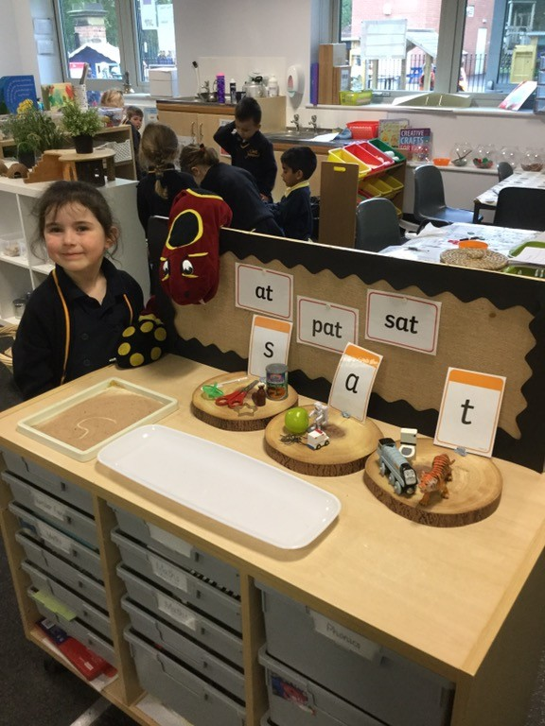
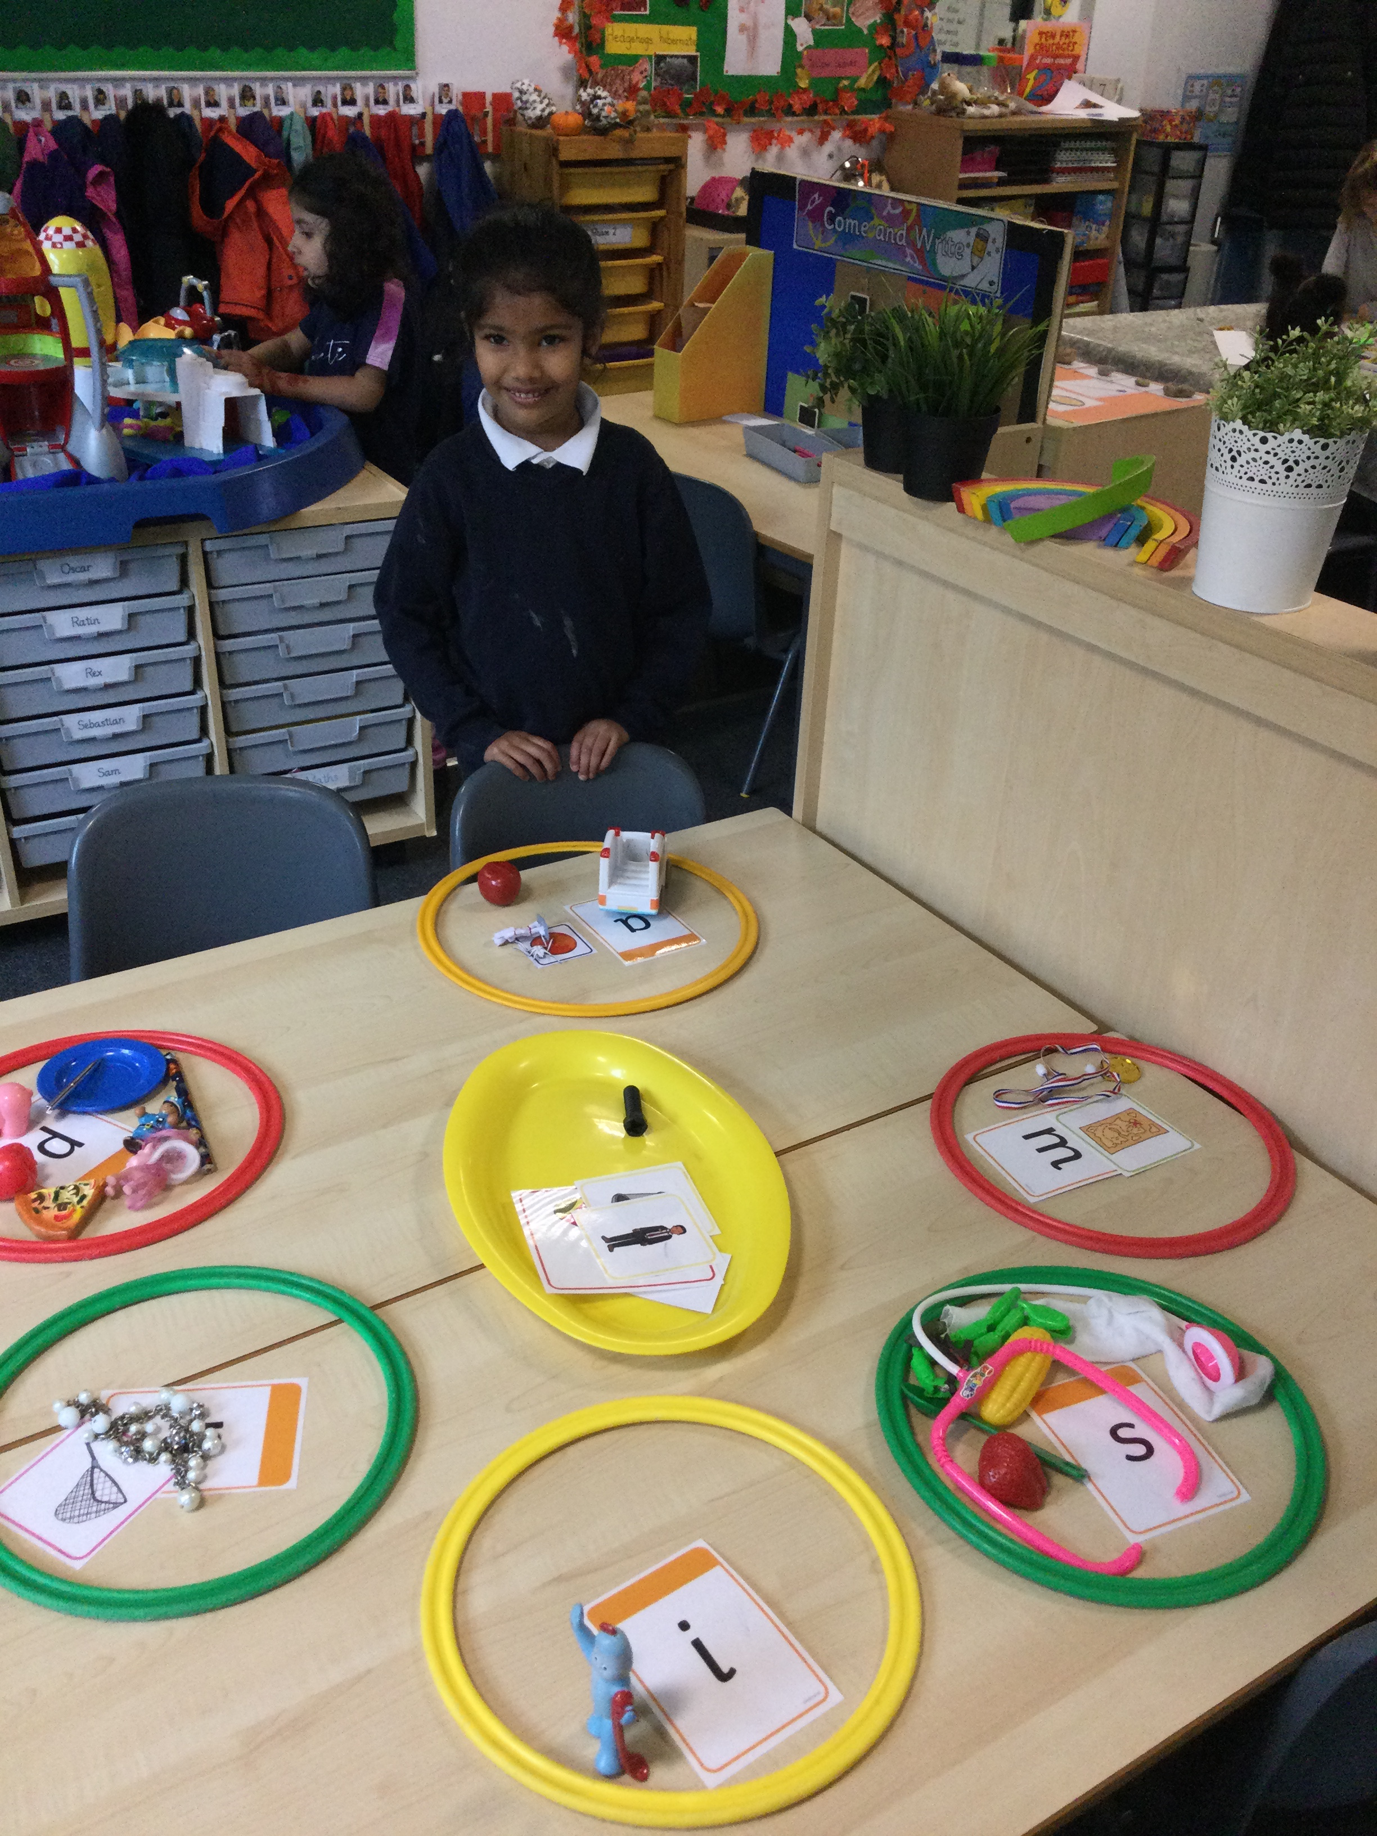

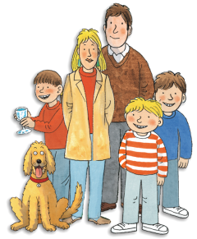

Why is reading so important?

- Early reading ignites creativity, sparks curiosity, and stimulates the imagination in young children. Often, this leads to role-play as children grow which helps to develop other skills such as empathy, problem-solving, and morality.
- It has astonishing benefits for children: comfort and reassurance, confidence and security, relaxation, happiness and fun. Giving a child time and full attention when reading them a story tells them they matter. It builds self-esteem, vocabulary, feeds imagination and even improves their sleeping patterns
- Evidence suggests that children who read for enjoyment every day not only perform better in reading tests than those who don’t, but also develop a broader vocabulary, increased general knowledge and a better understanding of other cultures.
- In fact, reading for pleasure is more likely to determine whether a child does well at school than their social or economic background.
The most important thing that you can do is to create a reading environment in your home and in your life. Have books in your home and make sure that your child sees that books and reading are an important part of your life. At West Jesmond, there is a book lending library after school each Friday to help you introduce new books to your children each week. Jesmond Library is also a fantastic local resource.

The best way to help your child is to read as many books as possible in both English and your child’s home language. Read anything that your child is interested in (including magazines, menus, etc). You don't have to read all (or any) of the words each time. Remember to use silly voices, make sound effects, pull faces, act things out, talk about what you can see, talk about what you both think and feel and have fun!

Phonics – Little and often practice of the sounds your child has been learning at school will help them remember and use the sounds more confidently. Working with your child daily for just five minutes every day is a great start! Each week your child will be given phonics homework linked to the sounds taught in class that week. They will also receive flashcards of each new sound as we learn them. These can be found in their phoneme envelope as part of their reading pack.

Building vocabulary - Build your child’s vocabulary in both English and their home language by talking about interesting words and objects. For example, "Look at that aeroplane! Those are the wings of the plane. Why do you think they are called wings?" When you are reading atop and take time to talk about new words that your child may not understand the meaning of, or a word that is an exciting one to use as an alternative – for example, learning instead of saying bi we can say enormous! Humongous!

Helpful Words – alongside learning phonics as a tool for reading, your child will also learn some helpful words. These are words which are very common in the English language and often cannot be sounded out. Supporting your child to read these by sight (that is, recognising the words without sounding out), will help them become a more fluent and confident reader.

General tips to support reading

Once is never enough! - Encourage your child to re-read favorite books and poems as well as their school reading scheme book. Re-reading helps children read more quickly and accurately.

Dig deeper into the story - Ask your child questions about the story you have just read. Say something like, "Why do you think he did that?". Please use the questions in the cover of your child's book to discuss the story.

Be patient - When your child is trying to sound out an unfamiliar word, give him or her time to do so. Remind your child to look closely at the first letter or letters of the word. Encourage your child to use their knowledge of phonics to segment and blend a word.

Pick books that are at the right level - Help your child pick books that are not too difficult. The aim is to give your child lots of successful reading experiences.

I read to you, you read to me - Take turns reading aloud at bedtime. Kids enjoy this special time with their parents.

One more time with feeling - When your child has sounded out an unfamiliar word, have him or her re-read that sentence. Often children are so busy figuring out a word they lose the meaning of what they've just read. You reading it back to them fluently can help them understand the word in context and hear what reading sounds like.

Listening games to play with your Reception child

Toy sounds – When your child is playing with their toys encourage them to make the right sounds. Farm animals, train sets, vehicles, dolls etc are great for this. Help your child to notice these sounds around and about. E.g. Listen to the sound that cars, trucks and fire engines make in the street. Practise making these noises, then use them with car, truck and fire engine toys.

Big ears – Cup your hands around your ears and listen to sounds all around. Talk about what sounds you can hear. Try doing this in the house, in the street, in the park, on the beach etc. Talk about the sounds: Are they loud or quiet? Are they short or long? Can you make a similar sound with your voice?

Shake it all about - Make simple shakers by filling socks, plastic bottles or tubs with rice, pasta, pebbles etc. Play with them and talk about the sounds that they make. Are the sounds soft, sharp, smooth, jiggly, scratchy?

Tap it out - Use the shakers above or use drums (pots and pans and wooden spoons are perfect) to play along with songs, rhymes and the radio. Try making the loudest sounds that you can then the quietest sounds that you can. Tap out simple rhythms. Can your child repeat the rhythm back to you?

Interesting instruments- If you see or hear instruments being played either in real life or on TV, talk about the sounds that the instrument makes. Which instruments does your child like the sound of best? Can they tell you why? Can they imitate the sound with their voice?

Song time- Sing your child’s favourite songs, ones they have learnt at school, songs you remember from childhood or songs on CDs you have at home. Encourage children to use their bodies to make sounds to go along with their singing – stamping, clapping, patting knees etc.

Sound effects- Read stories and encourage children to make sound effects with their body – stomping, knocking, clapping, scratching etc.

Rhyming books - When children are really familiar with a particular book, try pausing before the rhyming word. Encourage your child to fill in the missing word. Julia Donaldson books and Dr. Suess are great!

Clap it out- Encourage children to think about the rhythms in words. Say simple nursery rhymes and clap along with one clap for each syllable. Repeat with knee taps, head pats or stamps.

Talking about toys - Talk about your child's toys and say something about them that alliterates. It doesn't have to make much sense.
- Thomas the train travels on the tracks.
- Lion likes to lick lollies.
- Hippo huddles and cuddles me with his hairy head.
Can your child make suggestions? This is a tricky skill and it will take time. Praise them for trying and making suggestions even if they don't alliterate.

Quick draw - When drawing together, try drawing a snake and a sock. Point out that these things both begin with a 's' sound. Make the hissing s sound. Add some more 's' pictures e.g. snail, spider etc. Your child may be able to suggest some ideas as well.

Voice play - Encourage your child to use their voice to make a wide range of sounds. E.g. At the park:
Going up a ladder – clunk, clunk, clunk
Coming down a slide – whoosh
On a roundabout – wheee
Bouncing a ball – boing!

Pulling faces - Play around with moving your mouth in different ways e.g waggling your tongue, opening as wide as possible, smiling wide, frowning, blowing lips etc. You may want to do this to music or it can be a fun bath time game. Make a range of sounds e.g oo, ee, sh, th. Exaggerate your mouth shape while you are doing this to encourage your child to copy your mouth shape. It can be fun to do this while you are both looking in a mirror.

Phonics games to play with your Reception child

Oral Blending games
Robotic talking - Words are made up from sounds and children need to be able to hear these sounds individually. Sometimes when you are playing you can say words as if you were a robot (saying the sounds separately) and see if your child can work out what you are saying. Stick to short simple words that only have a few sounds in them. Make sure you are saying the letter sounds (p-i-g) not the letter names (pee-eye-gee). E.g.
Pass that p-i-g to me.
Sit d-ow-n.
Point to your t-ee-th.
Hop like a f-r-o-g.
As your child becomes familiar with this robot talking, see if they can say words in robot talk themselves?

I spy – Say the rhyme ‘I spy with my little eye something beginning with ______’ allow your child plenty of opportunities to guess what you have chosen, for example, ‘something beginning with t’ could be a tree, toy, tent or train.

Point out print everywhere - Talk about the written words you see in the world around you. Ask your child to find familiar words on each outing such as ‘McDonald’s; 'Coke’ or ‘Tesco'. 'Co-op' etc.

Playing with words – Encourage your child to sound out the word as you change it from mat to fat to sat; from sat to sag to sap; and from sap to sip.

Phoneme recognition games

Looking for letters – Ask your child to look for English letters whilst you are out and about. Can they find letters from their own name, letters they have learnt in school or letters that specific words begin with?

Fast letter sorting - You will need:
- A large piece of paper with three hoops drawn on to it.
- 12 small pieces of card with letters written on (4 sets of 3 letters)
Choose 3 sets of letters – 2 which the child knows and one new one. Spread the letter tiles out on the table making sure they are all the correct way up. Encourage your child to sort the letters into the correct hoop using both hands, saying each letter as they move it.

Letter discrimination You will need: A 3x3 grid
Write the letter you are learning with your child onto half of the spaces (for example c). Fill the rest with other letters. Ask your child to cover all the c’s with a counter as quick as they can.

Ladder letters
You will need: A drawing of a ladder/ladybird or flower, letter tiles and counters.
Make a pile of letter tiles (use a mixture of known and new letters). Place a counter at the bottom of the ladder and move up a rung for every letter they can read correctly. This game can be changed to covering spots on a ladybird, petals on a flower – go with your child’s interests if possible.

Letter sound bingo. You will need: A 3x3 grid for each player and counters or coins.
Write some of the letters into the spaces on each card, making each card slightly different. The ‘bingo caller’ says each letter in turn and the players cover the letter up. The winner is first to fill their board. To make this game easier for new readers, show them the letter for them to match.

Helpful Word games

Bingo – You will need: A board for each player and counters or coins
The list of words your child is currently learning, for example their spelling list or tricky words.

Write some of the words into the spaces on each card, making each card slightly different. The ‘bingo caller’ says each word in turn and the players cover the words up. The winner is first to fill their board. To make this game easier for new readers, show them the word for them to match.

Matching pairs – You will need: Small pieces of card or paper with the words your child is currently learning written on each. Each word will need to be written twice so you can search for a matching pair. Turn all the cards face down on the table. And take turns to turn over two. When a matching pair is found that player can keep them. The winner is the person with the most pairs at the end of the game.

Snap - Make a set of cards with words your child is learning written on. Ensure that each word is written on two separate cards. Shuffle up the cards and share them out. Each player takes turns to turn over their card, put it down and read the word. If it matches the previous card played, the first person to notice shouts 'snap!' and wins the pile. This game is best used to practise words your child knows fairly well, rather than new ones, as it's quite fast-paced.

Once your child knows a word reliably, you can take it out of the current pack of cards and bring in a new word. Every so often, play a game with the 'old' cards, so that your child doesn't forget them. It's a good idea to try and discard a known word and add a new word every day, once your child is getting the hang of learning new words.

Some useful websites and apps;

- Mr Thorne does phonics with Geraldine the Giraffe https://www.youtube.com/channel/UC7sW4j8p7k9D_qRRMUsGqyw

- https://www.phonicsplay.co.uk/

- Teach my monster to read app https://www.teachyourmonster.org/readingforfun?gclid=EAIaIQobChMIsqD6v9bV-gIVk2DmCh00NgRsEAAYASAAEgK-fPD_BwE

- Oxford Reading Owl e-book library https://www.oxfordowl.co.uk/for-home/find-a-book/library-page/

If we can help with phonics in any way, please speak to us at any time and we will be happy to help give ideas and support.

